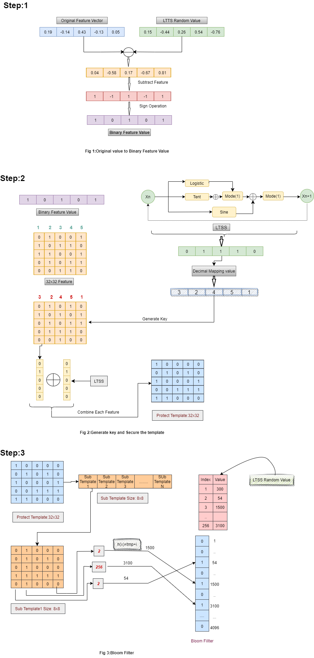

**EER:**

|  |  |  |
| --- | --- | --- |
| **Datasets** | **Same Key** | **Different Key** |
| FVC2002_DB1 | 0.12 | 0.10 |
| FVC2002_DB2 | 0.20 | 0.11 |
| FVC2002_DB3 | 0.27 | 0.16 |
| FVC2004_DB1 | 0.30 | 0.10 |
| FVC2004_DB2 | 0.20 | 0.11 |
| FVC2004_DB3 | 0.10 | 0.08 |

**Revocability:**

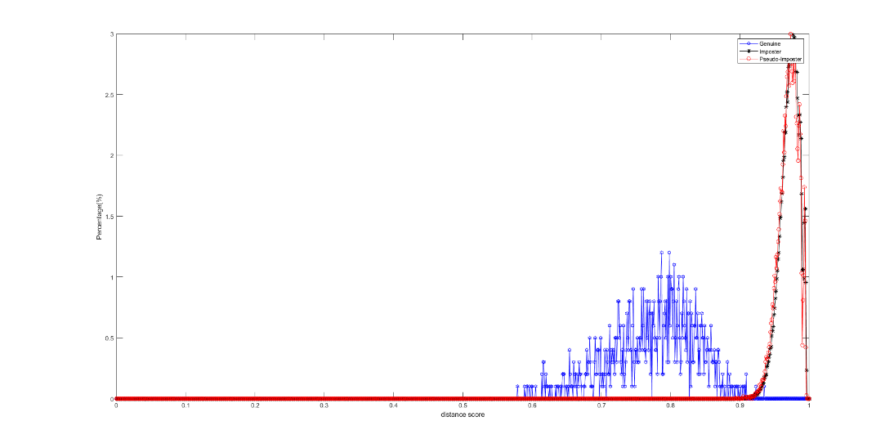

FVC2002_DB1

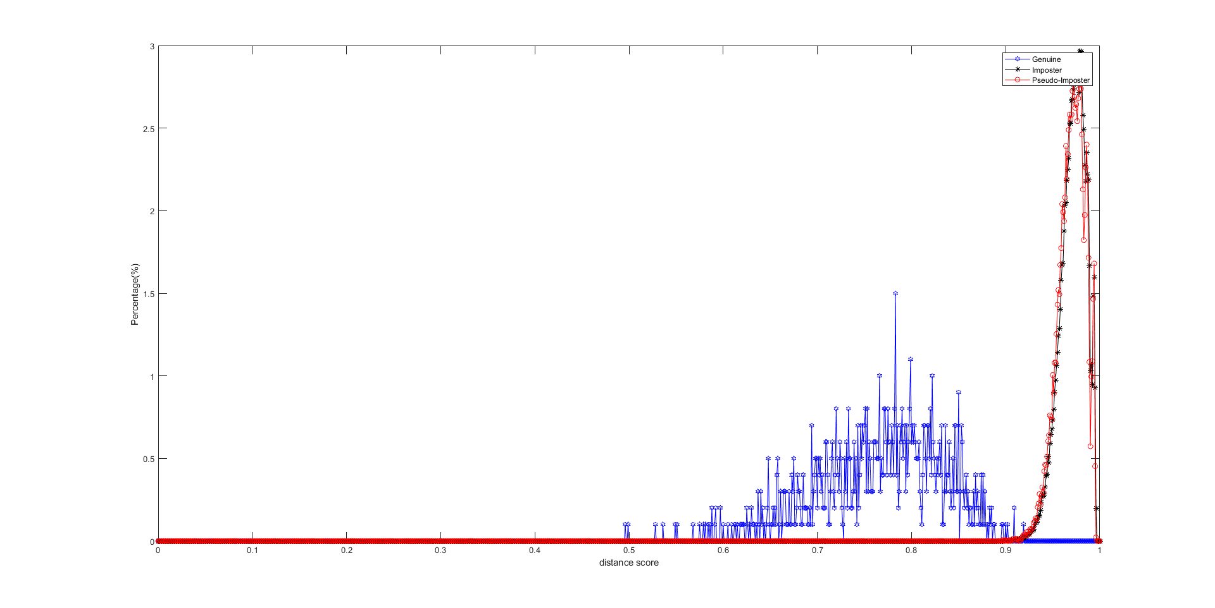

FVC2002_DB2

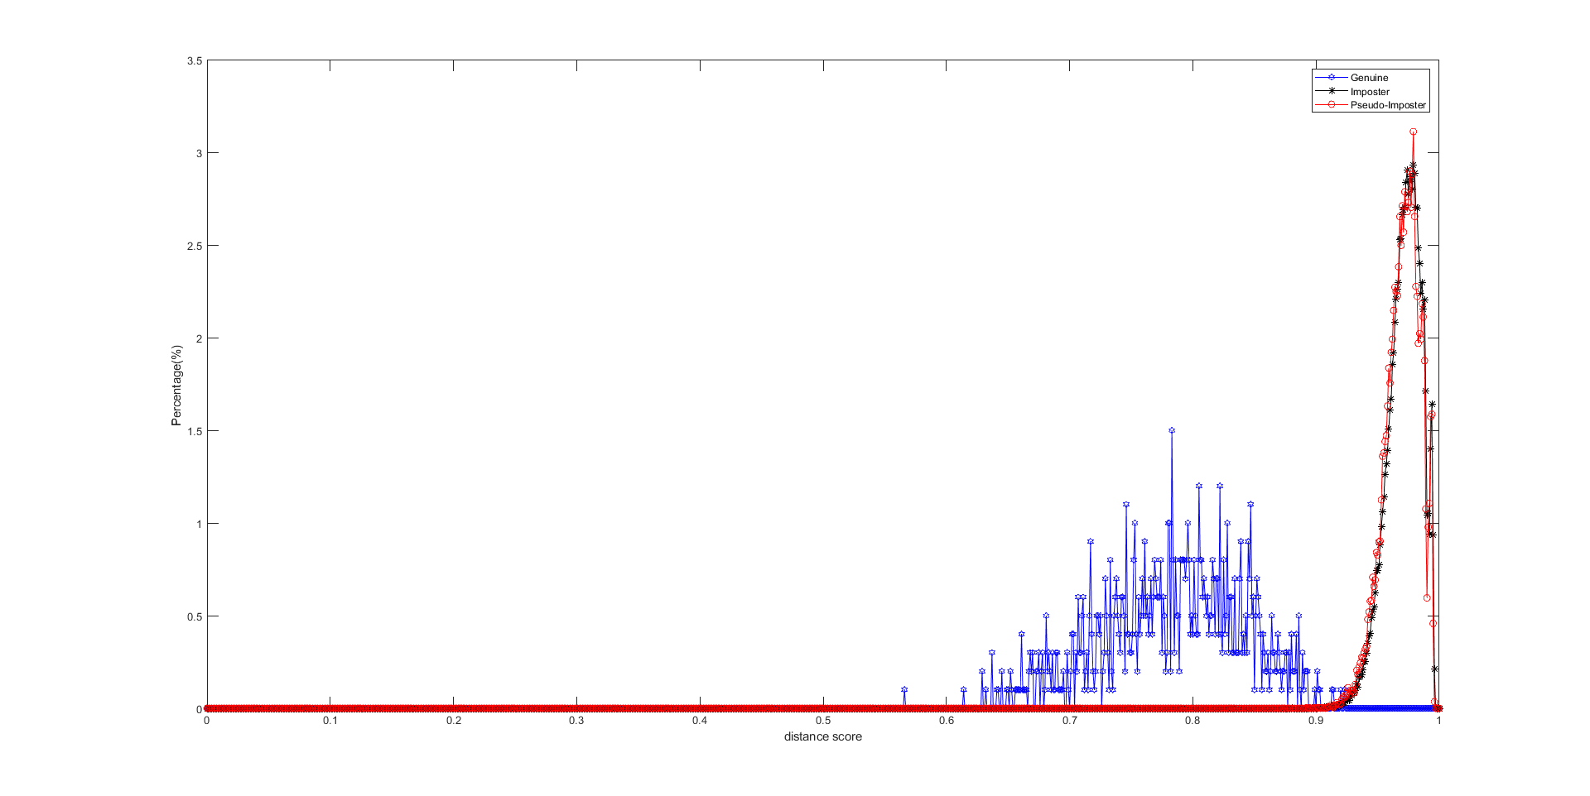

FVC2002_DB3

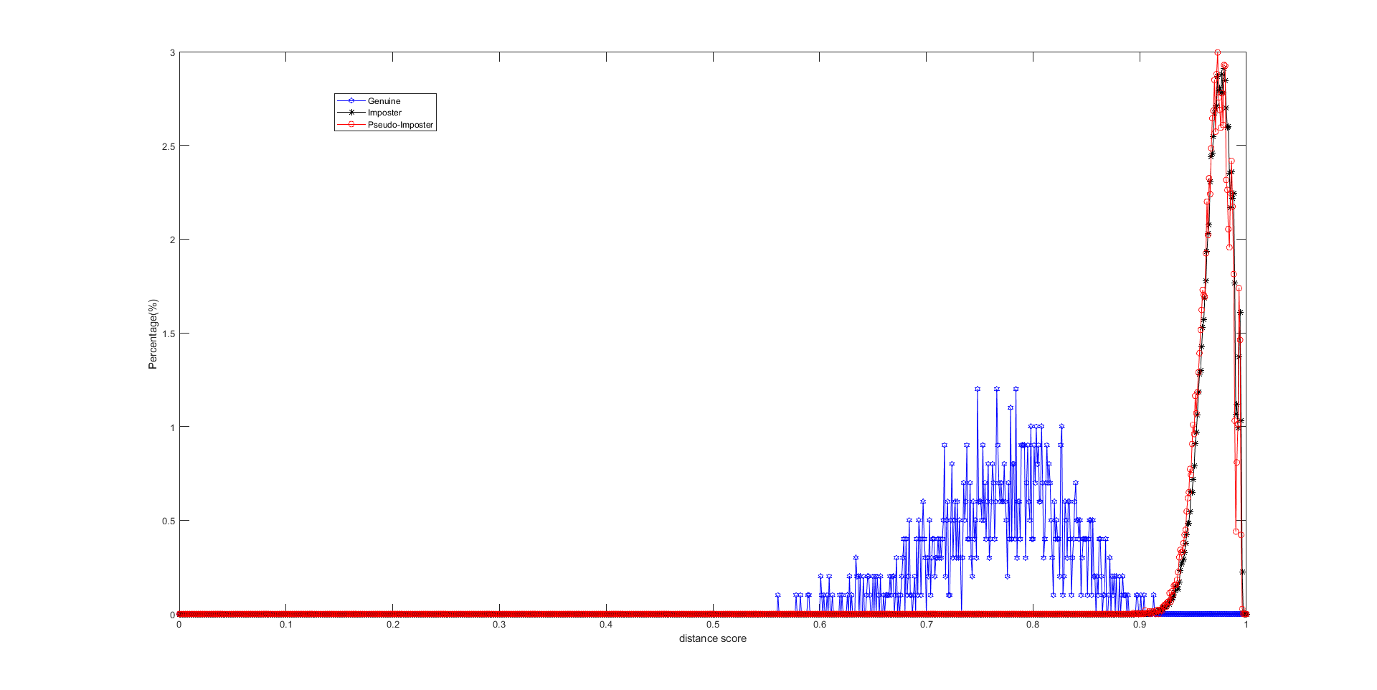

FVC2004_DB1

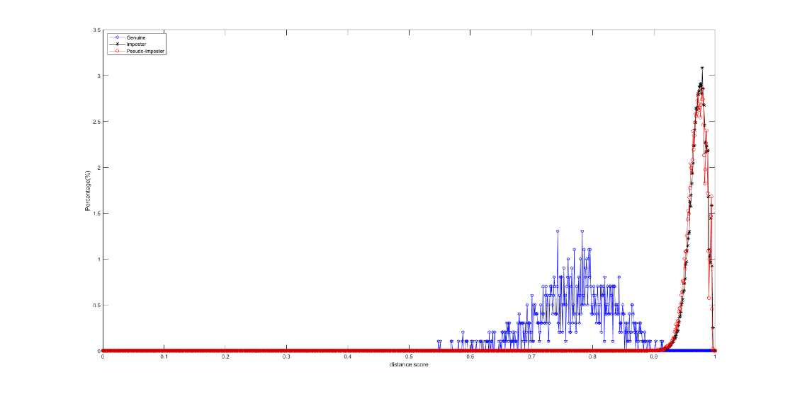

FVC2004_DB2

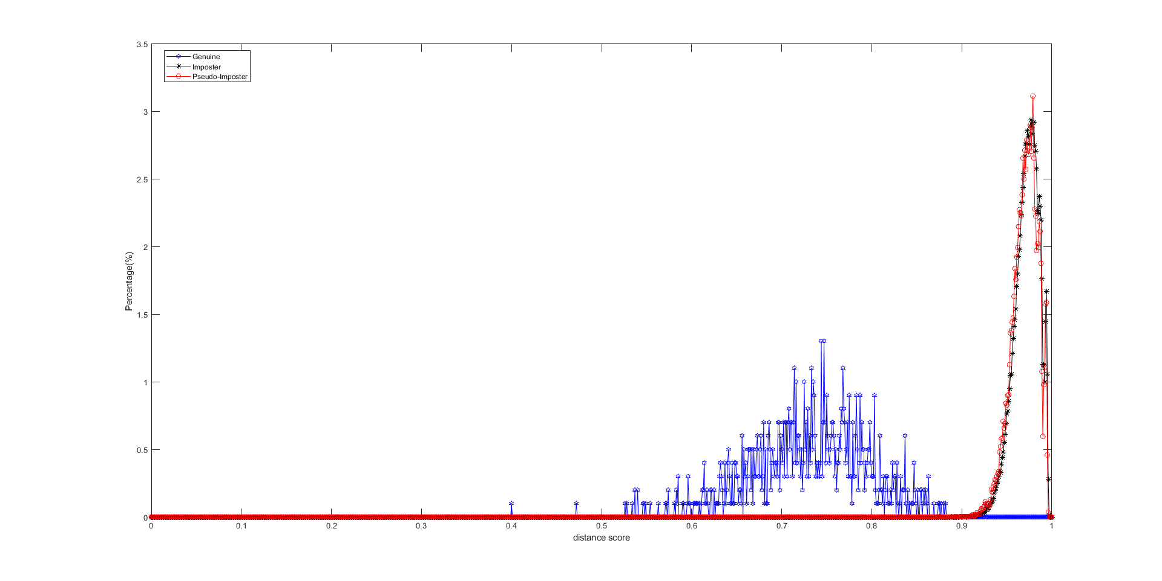

FVC2004_DB3

**Linkability:**

**Table 1: False Accept Attack Coplexity Analysis.**

|  |  |  |  |  |  |  |
| --- | --- | --- | --- | --- | --- | --- |
| Dataset | GAR | UBimp | T | NCSIZEC | T-UBimp | FA Complexity |
| FVC2002_DB1 | 85% | 0.491 | 0.301 | 24096 | 0.19 | 2778 |
| FVC2002_DB1 | 90% | 0.491 | 0.287 | 24096 | 0.20 | 2819 |
| FVC2002_DB1 | 95% | 0.491 | 0.271 | 24096 | 0.22 | 2901 |
| FVC2002_DB2 | 85% | 0.484 | 0.290 | 24096 | 0.19 | 2778 |
| FVC2002_DB2 | 90% | 0.484 | 0.281 | 24096 | 0.20 | 2819 |
| FVC2002_DB2 | 95% | 0.484 | 0.264 | 24096 | 0.22 | 2901 |
| FVC2002_DB3 | 85% | 0.493 | 0.317 | 24096 | 0.17 | 2696 |
| FVC2002_DB3 | 90% | 0.493 | 0.305 | 24096 | 0.18 | 2737 |
| FVC2002_DB3 | 95% | 0.493 | 0.292 | 24096 | 0.20 | 2819 |
| FVC2004_DB1 | 85% | 0.487 | 0.299 | 24096 | 0.18 | 2737 |
| FVC2004_DB1 | 90% | 0.487 | 0.291 | 24096 | 0.19 | 2778 |
| FVC2004_DB1 | 95% | 0.487 | 0.277 | 24096 | 0.21 | 2860 |
| FVC2004_DB2 | 85% | 0.483 | 0.303 | 24096 | 0.18 | 2737 |
| FVC2004_DB2 | 90% | 0.483 | 0.293 | 24096 | 0.19 | 2778 |
| FVC2004_DB2 | 95% | 0.483 | 0.279 | 24096 | 0.20 | 2819 |
| FVC2004_DB3 | 85% | 0.462 | 0.264 | 24096 | 0.19 | 2778 |
| FVC2004_DB3 | 90% | 0.462 | 0.255 | 24096 | 0.20 | 2819 |
| FVC2004_DB3 | 95% | 0.462 | 0.243 | 24096 | 0.21 | 2860 |

**Table 2: Birthday Attack Complexity Analysis.**

|  |  |  |  |  |  |  |  |
| --- | --- | --- | --- | --- | --- | --- | --- |
| Dataset | GAR | UBimp | NCSIZEC | T | FA Complexity | P | BA Complexity |
| FVC2002_DB1 | 85% | 0.491 | 24096 | 0.301 | 2778 | 0.707 | 2550 |
| FVC2002_DB1 | 90% | 0.491 | 24096 | 0.287 | 2819 | 0.707 | 2579 |
| FVC2002_DB1 | 95% | 0.491 | 24096 | 0.271 | 2901 | 0.707 | 2637 |
| FVC2002_DB2 | 85% | 0.484 | 24096 | 0.290 | 2778 | 0.707 | 2550 |
| FVC2002_DB2 | 90% | 0.484 | 24096 | 0.281 | 2819 | 0.707 | 2579 |
| FVC2002_DB2 | 95% | 0.484 | 24096 | 0.264 | 2901 | 0.707 | 2637 |
| FVC2002_DB3 | 85% | 0.493 | 24096 | 0.317 | 2696 | 0.707 | 2492 |
| FVC2002_DB3 | 90% | 0.493 | 24096 | 0.305 | 2737 | 0.707 | 2521 |
| FVC2002_DB3 | 95% | 0.493 | 24096 | 0.292 | 2819 | 0.707 | 2579 |
| FVC2004_DB1 | 85% | 0.487 | 24096 | 0.299 | 2737 | 0.707 | 2521 |
| FVC2004_DB1 | 90% | 0.487 | 24096 | 0.291 | 2778 | 0.707 | 2550 |
| FVC2004_DB1 | 95% | 0.487 | 24096 | 0.277 | 2860 | 0.707 | 2608 |
| FVC2004_DB2 | 85% | 0.483 | 24096 | 0.303 | 2737 | 0.707 | 2521 |
| FVC2004_DB2 | 90% | 0.483 | 24096 | 0.293 | 2778 | 0.707 | 2550 |
| FVC2004_DB2 | 95% | 0.483 | 24096 | 0.279 | 2819 | 0.707 | 2579 |
| FVC2004_DB3 | 85% | 0.462 | 24096 | 0.264 | 2778 | 0.707 | 2550 |
| FVC2004_DB3 | 90% | 0.462 | 24096 | 0.255 | 2819 | 0.707 | 2579 |
| FVC2004_DB3 | 95% | 0.462 | 24096 | 0.243 | 2860 | 0.707 | 2608 |